# How To Perform a PMO Assessment

The aim of a PMO Assessment and Strategy is to assess the current status of project management and the current project portfolio within the organization.

## PMO ASSESSMENT

* One of the goals of this exercise is to develop a desired future state for project management within the organization and then perform a gap analysis between the current and future states.
* The goal of the assessment activity is to find the issues, gaps, challenges and key decisions to be made about the current project management environment and project portfolio.

## KEY ACTIVITIES OF PMO ASSESSMENT

* Identify senior sponsor.
* Create a PMO steering committee.
* Assessment of current portfolio and state of project management and governance.
* Determine existing processes and tools.
* Define future state of project management and governance.
* Perform a gap analysis.
* Document assumptions, constraints and risks.
* Develop PMO strategy proposal as part of a PMO project brief and outline business case and budget.
* Gain approval from the PMO steering committee to go ahead to the next phase to start the setup and development of a PMO.

## THE ASSESSMENT PROCESS

### 1) IDENTIFY SENIOR MANAGEMENT PMO SPONSOR

* Identify a senior management sponsor for the PMO. **(This step is an absolute ‘must have’.)**
* Without a senior executive sponsorship mandating the need of a PMO, you will find it very difficult, even impossible, to carry out or gain agreement at any level for your initiative.
* The Executive Sponsor is the person that is ultimately responsible for overseeing and certifying the accuracy, viability, and defensibility of the PMO at the Organizational Level.
* In addition to getting everyone to follow the new processes, executive sponsorship will also ease the change management challenges that come with instituting new project management processes inside and outside of IT.
* **Executive Sponsor has the following roles and responsibilities:**
  + Champion the PMO.
  + Provide high-level oversight, direction, and support.
  + Provide escalation remedy.
  + Ensure the PMO meets its goals.
  + Approve major scope changes to PMO.
  + Provide resources, if applicable.
  + Approve PMO Charter with PMO Steering Committee.

### 2) APPOINT A PMO STEERING COMMITTEE

* Create a PMO Steering Committee of key stakeholders to work with the PMO Sponsor on behalf of the Executive Team to set the direction for the PMO, provide leadership and drive decision-making.
* Working with the PMO Sponsor, create a PMO Steering Committee by identifying and nominating key stakeholders.
* In the establishment of the PMO in a later phase, it is an easy win to pick one of the key projects of a member of the PMO Sponsorship team as a pilot project as a pilot project.
* Involvement and approval from these influential stakeholders of the PMO Steering Committee the development of the PMO and in the determination of standards is a key success factor for the PMO.

### 3) REVIEW CURRENT PROJECT PORTFOLIO

* This includes carrying out a review of any existing project-based structures and a high-level assessment of the current portfolio of projects.
* Assess and state the business problems driving the need for a PMO.
* Also included in the scope of the review, of how projects are done today, the perception of project management and what things are valued.

### 4) REVIEW EXISTING PROCESSES

* Establish what existing project management methodology and governance reporting are in place.
* Use process mapping to name requirements which are critical to the success of the PMO.
* Process mapping will help to arrive at a full view of requirements including both the requirements to be addressed by the PMO and the requirements to be addressed outside of the PMO.
* Highlight where the current processes for managing projects and resources and where project performance below management expectations.

### 5) DETERMINE THE FUTURE DESIRED STATE FOR PROJECT MANAGEMENT

* Outline a desired future state for project management within the organization based on the assessment findings and strategic goals.
* Some aspects and benefits of a future state would include predictability, cost savings in avoiding failed projects and project pitfalls, the creation of a common understanding, and project assurance to meet organization, industry and regulatory requirements.
* Developing measures for success for this future state is also a value-added exercise to make sure any future state is tied to reality and can be measured.
* This will keep the PMO set up process on track and aligned to business needs, and not a project management methodology and process focus.
* The goal for the PMO is to be a customer-focused organization where decision processes allow organized, rational priority decisions using trusted information to support continuous planning for the life cycle of investments.
* The future state aim should be a transparent environment where the economic value of the total IT portfolio is known and credible and the focus is on delivering real benefits with the business sponsors and IT are held jointly accountable for benefits.
* Where customers voluntarily and actively participate in the decision process and where decision criteria and process are transparent, accepted and used by other parts of the business.
* After creating the first vision and strategy, refine it with feedback from the PMO Steering Committee.

### 6) PERFORM A GAP ANALYSIS

* Perform a gap analysis between the desired future state and the current state. This analysis will form the basis of an initial PMO Strategy and an Outline Business Case.

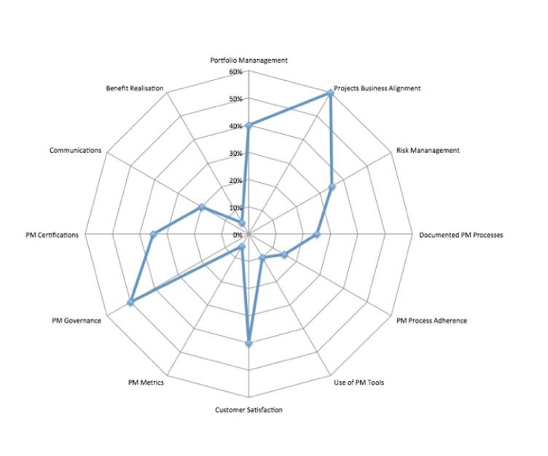

*Radar diagrams are useful for displaying and presenting PM Assessment findings to identify key opportunities for improvement and ‘quick win” areas for the PMO in establishing its credibility and value.*

* The aim of a PMO Assessment and Strategy is to assess the current status of project management and the current project portfolio within the organization.
* One of the goals of this exercise is to develop a desired future state for project management within the organization and then perform a gap analysis between the current and future states.

### 7) DOCUMENT ASSUMPTIONS, CONSTRAINTS AND RISKS

* Identify assumptions, constraints and risks and any mitigating activities required.

### 8) DEVELOP A PMO STRATEGY

* Defining a strategy will help get the PMO aligned with the other strategies in the rest of the organization.
* The Gap Analysis will offer a framework to develop a PMO Strategy and to find “Quick Wins” for the PMO.
* Have clear tactical and strategic goals to better prioritize projects with business partners and to make the business more effective through technology.

### 9) GAIN APPROVAL TO DO A PMO INITIATION PHASE

* Present Assessment findings, recommendations, draft PMO strategy and vision and outline business case for PMO.
* Gain approval to go to the next phase for Project Initiation.

## TYPICAL PROBLEMS FROM ASSESSMENTS

* Here are some typical project management issues found in assessments of current environments.

### a) INCONSISTENT PROCESSES AND REPORTING

* Projects are finishing late and usually also running over budget with project managers using their own individual processes and communications methods.
* There is an organizational need for internal project management processes and communications to improve much.
* With a lack of focus on project schedules and inconsistent and inaccurate project reporting, there is often no mechanism for early warning of issues and risks and any issues and risks are handled in an ad-hoc reactive way.

### b) Resource Management Issues

* Often a prior lack of planning upfront increases the ineffective use of resources.
* Scarce resources are overcommitted due to the organization having difficulty prioritizing work especially between business projects and tactical IT “business as usual “ projects.

### c) A LACK OF CENTRALIZED PLANNING

* Due to a lack of a consolidated centralized operational plan, managers are not confident of knowing what their organization is working on or what the priorities are for different projects within the business.
* In addition, a lack of a comprehensive view provides inflexibility for senior management to make better and quicker decisions.

### d) A LACK OF CONSISTENT PROJECT MANAGEMENT TOOLS

* A lack of predictable, reusable project management tools and techniques to improve project success, communication, and teamwork.

# SUMMARY

## 1) SOME PMO STRATEGY GUIDING PRINCIPLES

* Be a consultative organization.
* Provide support to key stakeholders.
* Focus on value-added activities.
* Be flexible in approach.
* Be a service orientated organization.
* Do not forget that PM’s are important stakeholders also.
* Make communications and reporting the business driver for the PMO.
* Focus on doing a few things excellent and not doing too much.
* A key goal of a PMO strategy is to decide the PMO reporting relationship.

## 2) SOME RECOMMENDED BEST PRACTICES

* It is considered a best practice to have the project management office report to the CIO’s office, it truly becomes a central place for project management and mentoring.
* It also ensures that standards and process changes happen at the highest level inside the organization.
* The PMO strategy and the Outline Business Case will be submitted the PMO Steering Committee for approval to go ahead to a PMO initiation phase.